**Report: Hockey Clubs in Belgium. Potential location for new club.**

Jeffrey Balrak

November 15, 2019,

**Problem Statement**

Field Hockey is a booming sport in Belgium, with our national hockey team being nr 1 in the world. New clubs are being opened.

How is the distribution of hockey clubs across Flanders?   
By plotting the Flanders communes and the hockeyclubs, we can visualize where there is potential for starting a new club.

Where there is potential, it’s key the local communes sponsor the investment as it is high cost. An existing sports facility which can be expanded or which can be shared with other sports (e.g. soccer) increases the chance an investment will be made.   
This analysis will help identifying locations and likely targets. Call it the best next location.

Target audience is the Belgian hockey federation who is tasked to organize and promote success of national hockey.

**Data**

* Online listing of all hockey clubs in Flanders, including address and number of members.
* Online Wikipedia article describing all Flanders communes
* Foursquare data describing existing Athletics & Sports venues in areas where a hockey investment could be made

**Methodology**

* Using BeautifulSoup to extract online html data into a pandas dataframe for further analysis
* Using geopy to plot communes and hockey clubs on a Flanders map
* Visually identify large areas with no hockey club presence
* Identify communes located centrally in those areas, i.e. at largest distance from existing hockey clubs
* Using Foursquare to identify those areas with the most existing sports infrastructure

**Results**

* The analysis identifies a few areas where a large rectangular square can be drawn without any hockey clubs. Communes in the center of these squares could potentially be locations where travelling distance prevents youth from practicing hockey

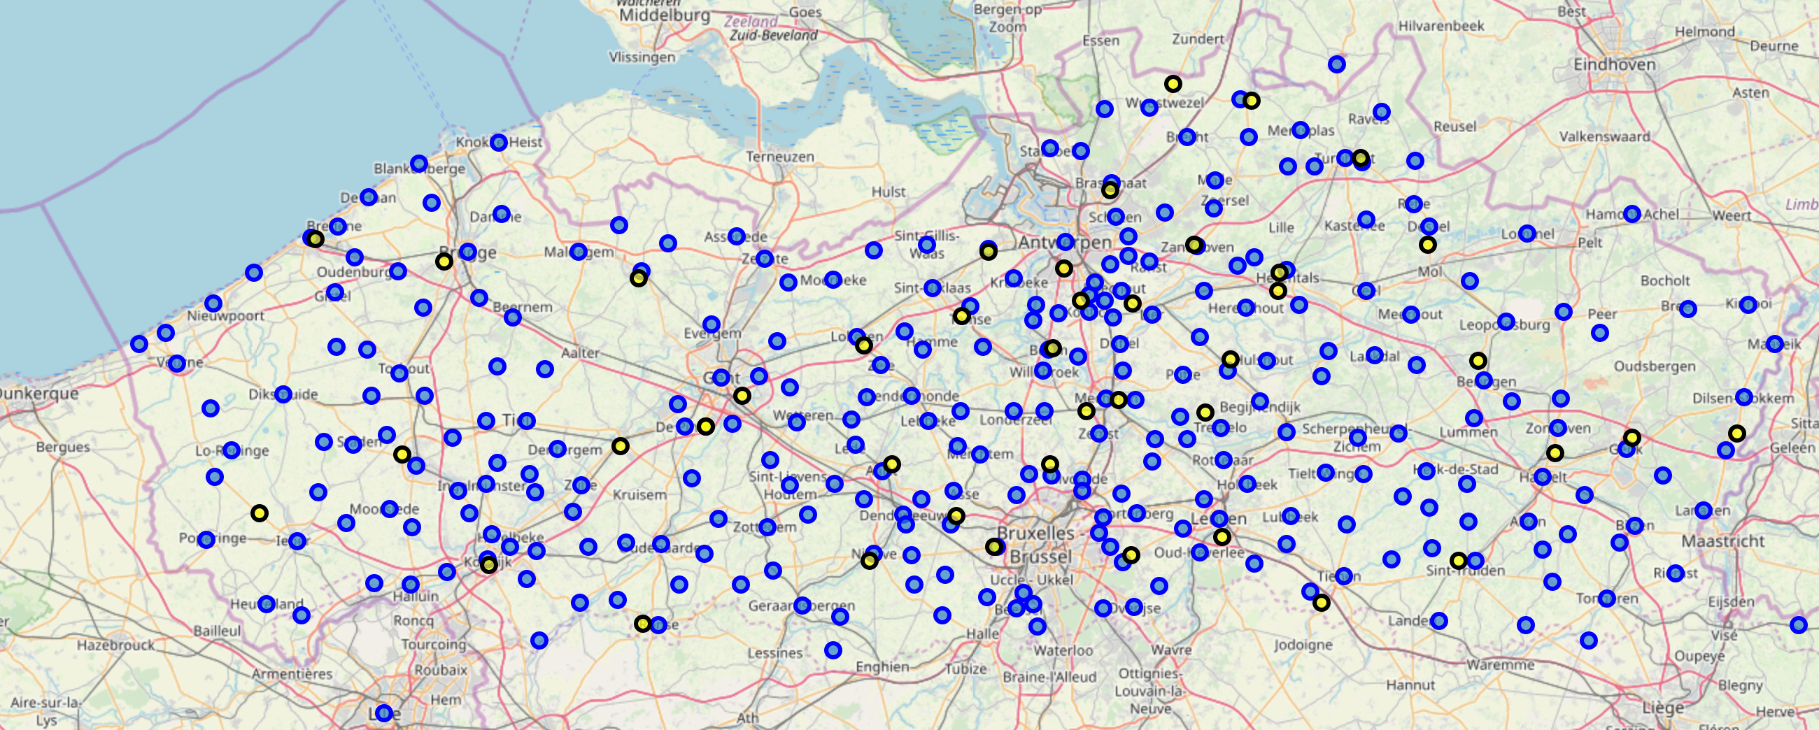

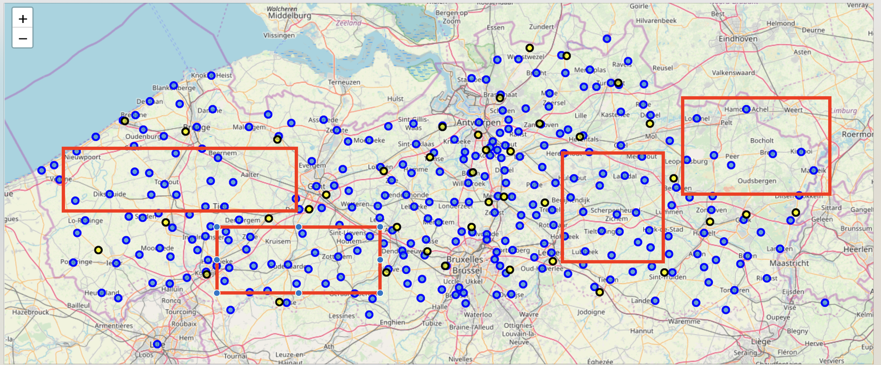

* Torhout, Oudenaarde, Scherpenheuvel, Bree are potential locations as they are communes with no hockey club in proximity. Bree can be skipped as the number of communes (population) surrounding it is relatively low.
* Using Foursquare analysis data, it is clear that Torhout and Oudendaarde has the biggest potential due to the largest existing sports infrastructures which could be used to expand with hockey activity.

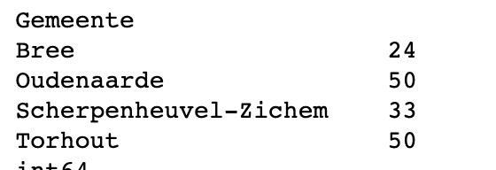

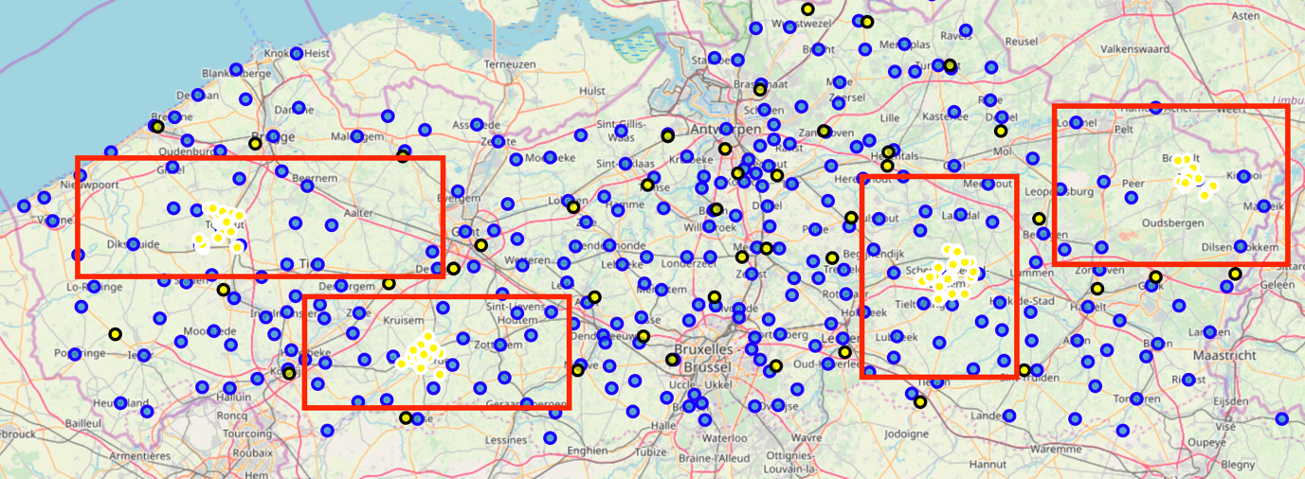

**Conclusion**

* Flanders is becoming saturated with hockey clubs. There are still areas with no coverage
* Amongst the 4 communes we identified as being located in an area with no hockey presence, there are 2 which stand out being in an area with the most sports infrastructure. Oudenaarde and Torhout.
* These communes would be worth additional investigation to determine if a new hockey club would be beneficial.
* Foursquare data should be used with caution, especially when selecting on category. The Athletics and Sport venues also include Sports therapists. This can be argued and would not benefit this analysis which primarily needed outdoor sports venues.
* As the sports is still booming, a deeper analysis will be required to see if additional clubs could thrive